Mothering God
Co-Pastor Susanne Guenther Loewen
NPMC – Mother’s Day, May 9, 2021

Scripture: Exodus 2:1-10, Isaiah 49:13-17
Hymns: Like a Mother who has Borne Us - VT 518
Now Thank we all our God - VT 114

Exodus 2:1-10 (NRSV):
Now a man from the house of Levi went and married a Levite woman. ² The woman conceived and bore a son; and when she saw that he was a fine baby, she hid him three months. ³ When she could hide him no longer she got a papyrus basket for him, and plastered it with bitumen and pitch; she put the child in it and placed it among the reeds on the bank of the river. ⁴ His sister stood at a distance, to see what would happen to him.
⁵ The daughter of Pharaoh came down to bathe at the river, while her attendants walked beside the river. She saw the basket among the reeds and sent her maid to bring it. ⁶ When she opened it, she saw the child. He was crying, and she took pity on him. “This must be one of the Hebrews’ children,” she said. ⁷ Then his sister said to Pharaoh’s daughter, “Shall I go and get you a nurse from the Hebrew women to nurse the child for you?” ⁸ Pharaoh’s daughter said to her, “Yes.” So the girl went and called the child’s mother. ⁹ Pharaoh’s daughter said to her, “Take this child and nurse it for me, and I will give you your wages.” So the woman took the child and nursed it. ¹⁰ When the child grew up, she brought him to Pharaoh’s daughter, and she took him as her son. She named him Moses, “because,” she said, “I drew him out of the water.”

Isaiah 49:13-17:
Sing for joy, O heavens, and exult, O earth;
break forth, O mountains, into singing!
For the Lord has comforted his people,
and will have compassion on his suffering ones.
¹⁴ But Zion said, “The Lord has forsaken me,
my Lord has forgotten me.”
¹⁵ Can a woman forget her nursing child,
or show no compassion for the child of her womb?
Even these may forget,
yet I will not forget you.
¹⁶ See, I have inscribed you on the palms of my hands;
your walls are continually before me.
¹⁷ Your builders outdo your destroyers,
and those who laid you waste go away from you.

I want to begin this morning by talking about treaties. We’ve gotten very used to beginning our worship services with a short land acknowledgement, as we did today, naming that this is Treaty 6 territory and the homeland of the Métis Nation. Many of us think of this as a way of acknowledging the history of this land, the peace agreement or contract made between European settlers and the Indigenous nations that had lived here for millennia before. But I recently read a Cree or nêhiyaw perspective on Treaty 6 that made me rethink the whole practice.
Sylvia McAdam, who is a Cree lawyer from Whitefish Lake Reserve 118 in Saskatchewan, says that the written treaty documents only tell the European side of the story. The Cree perspective is that the treaties were about adoption. She writes,
When treaties became binding, it became a ceremonial covenant of adoption between two families. 'kiciwâminawak, our cousins: that is what my elders said to call you.' In nêhiyaw [Cree] law, the treaties were adoptions of one nation by another. At Treaty 6 the nêhiyawak adopted the Queen and her children. We became relatives. … These kinship relationships were active choices, a state of relatedness or connection by adoption.

So according to McAdam, when we acknowledge the treaty, we are actually naming each other as family, even chosen family. What a powerful shift in perspective!
Today is Mother’s Day, a day that is also about family, specifically expressing gratitude for the mothers and mother-figures in our lives. While it’s important to celebrate the mothers in our lives, I also think we sometimes gloss over the complexity of motherhood on Mother’s Day. Our society sometimes takes the hard work of mothers for granted, or assumes motherhood is somehow an automatic part of being a woman rather than something that is chosen and learned and takes skill, strength, and patience (so much patience!). Some have chosen to speak of “mothering” as a verb instead of “motherhood” to recognize this difference. And we know that not everyone experiences mothering in the same way. I’ve appreciated this illustration that’s been going around, which names different experiences of being or relating to mothers:
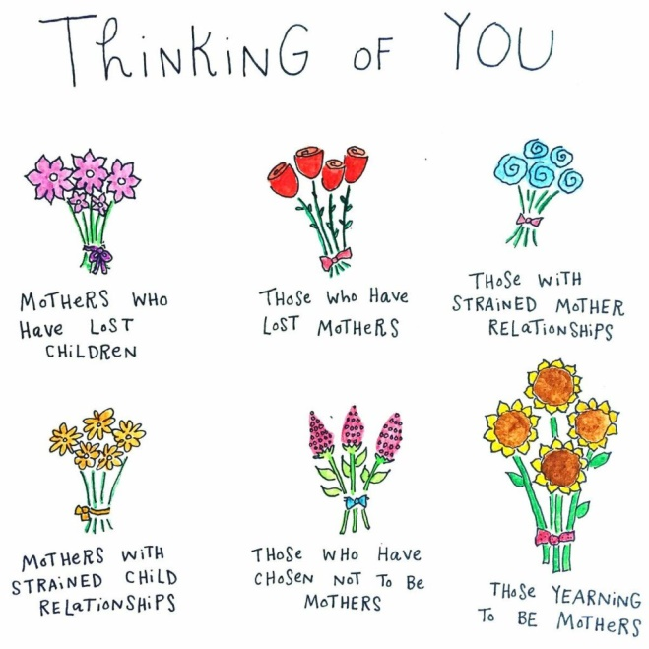
- Some long to be mothers but are not able to have children
- Some have lost children; some children have lost mothers
- Some have strained relationships with their mothers
- Some have chosen not to be mothers and feel judgment over that decision
- Some have adopted children
- Some “mother” the children in their lives as mother-figures
- Some are foster mothers, who love a child for a time and then say goodbye
In other words, as much as our culture sometimes idealizes them, mothers and mothering are very human, and as such just as complex as other parts of our lives.
Our first Scripture text for today from Exodus 2 gives us one example of a complex family that raised one of the most important leaders of the ancient Israelites: Moses. We know this story well from Sunday school, but I wonder if we’ve paid much attention to the two mothers and the choices they make to keep Moses safe in very uncertain circumstances. It’s the time of Israelite slavery in Egypt, and the pharaoh of the day is hostile to the Hebrews. He doesn’t like how many of them there are, so he makes a cruel decree for the midwives to kill all the baby boys – something that will be echoed in Herod’s decree in the Gospel of Matthew, in Jesus’ time. But, like Jesus, baby Moses manages to survive this death threat because of the ingenuity of a number of women. First, in the chapter before ours there are the clever midwives, Shiphrah and Puah, who use Pharaoh’s own racist logic against him. They claim that the Hebrew women just give birth differently – very quickly – and the midwives aren’t able to get there in time to do away with the baby boys. The gullible pharaoh seems to believe them, and the midwives save many, many lives, including that of baby Moses.
Then there is Moses’ birth mother, who is not named in the Bible. We are told that she hides her infant son for as long as she can – for three months. I can imagine that those must have been terrifying months, trying to hide a baby, worrying about him, fearful that his cry would give him away and that he would be taken from her. So, “when she could hide him no longer,” she does what desperate mothers do for the sake of their children: she comes up with a plan to save his life. It’s a pretty risky plan, but it’s his only chance at survival. “[S]he got a papyrus basket for him, and plastered it with bitumen and pitch; she put the child in it and placed it among the reeds on the bank of the river.” And his sister – who will become Miriam, the prophet – stands by and watches over him (Exodus 2:3-4). She hands him over to the river, with only his sister to watch over him.
Or does she? I remember thinking previously what a fortunate – maybe even providential – turn of events that Pharaoh’s daughter found the baby so soon! How risky for Moses’ mother to leave things to chance like that. But in rereading this story, I recognized that this wasn’t just luck – it was strategy. Moses’ mother must have known where the Egyptian princess bathed, and chose that part of the river for her little baby basket, the little ark that carried such precious cargo. And so the princess happens to find the basket, and the baby. But there was no guarantee that the princess would “take pity on him.” She recognizes right away that “This must be one of the Hebrews’ children.” As soon as she says this, Miriam steps forward and offers to find a Hebrew nurse to nurse this baby.
Notice that there is an immediate assumption that the princess will adopt this baby as her own; she doesn’t hesitate at all. Imagine, finding a baby and immediately taking responsibility for raising it as your own! And when Miriam offers to find a nurse, the princess must have had some sense that this could be the baby’s birth mother. And yet she offers to pay the woman. Moses’ birth mother ends up being paid to nurse her own baby, and to spend a few more precious years with him! And so the two mothers of Moses – one Hebrew, one Egyptian, one a slave, the other royalty, one who gave birth to him, and one who adopted him – come to an agreement. They agree to raise this child together, to protect his life – in defiance of the Pharaoh’s orders. Moses’ birth mother is paid to nurse her own baby, and “When the child grew up, she brought him to Pharaoh’s daughter, and she took him as her son. She named him Moses, ‘because,’ she said, ‘I drew him out of the water’” (v. 5-10).
This story of Moses’ two mothers has a lot to teach us, I think, about what it means to be a parent. In the midst of harrowing circumstances, these two women do what they can to protect this vulnerable child. Both of them take risks for his sake, and in doing so, show great strength and compassion. The word for “pity” used for the Egyptian princess can also be translated as “compassion,” and in Hebrew, this word compassion is related to the word for womb. “Compassion” in Hebrew is rakhum, and “womb” is rekhem. So to be compassionate is tied to being maternal in the very best sense, according to the biblical tradition. And both of Moses’ mothers live out this compassion in this brief account. Thanks to these strong women who worked together to raise him, Moses grew to be a leader capable of leading a whole nation out of slavery.
Of course, there is another biblical figure who is often described as compassionate – God! One of the most common descriptions for God in the Hebrew Scriptures is that God is “merciful and gracious, slow to anger, and abounding in steadfast love” (Exodus 34:6). It’s used in Exodus as God’s first self-description, or articulation of who God is. God is the God who has mercy – who is compassionate – compassionate to the point of hearing the cries of the Hebrew slaves and leading them out of Egypt. This is a God who loves as fiercely as a mother, with great depth of compassion. And there are several passages that make this connection between mothering and God even more clearly.
Isaiah 49, our other text for today, is one such passage. In the context of the exile in Babylon, centuries after Moses and the exodus from Egypt, we again see a God who is compassionate to those who suffer. Verse 13 begins with a call to praise, because “the Lord has comforted [God’s] people, and will have compassion on [God’s] suffering ones.” When Zion does not believe this, the prophet Isaiah speaks of God as a nursing mother, saying,
Can a woman forget her nursing child,
or show no compassion for the child of her womb?
Even these may forget,
yet I will not forget you.
See, I have inscribed you on the palms of my hands (v. 15-16).
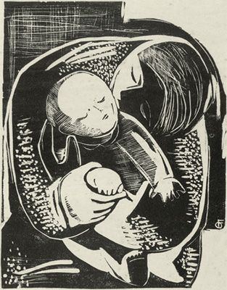
Notice the parallel between compassion and womb, there, which in Hebrew sound so similar. Here God’s love for us is that of the one who gives and preserves and nourishes life – it is an intimate embrace of love that nourishes us and meets our needs. And yet these verses go so far as to recognize that human mothers are, well, human. Even if our human mothers forget us – whether through age or injury or something else beyond their control – God will not forget us. Even if our human mothers cannot mother us for whatever reason, God will be our mother. God has written us on the palms of God’s hands; we belong to her. The final verse talks somewhat cryptically about building and destroying, and I take it to mean this: that even in the midst of bewildering traumas like exile and destruction and broken relationships, God is the one who always chooses compassion and creation. God is the one who rebuilds what we thought was irredeemably destroyed. Our Mothering God is the one who has, as poet Adrienne Rich says, “A passion to make and make again / where such un-making reigns.”
So today, as we give thanks for the people in our lives who mother us, we are also grateful for the compassion of our Mothering God, the one who will never forsake us. I want to close with a Mother’s Day prayer by Carol Penner:

Prayer to the Mother of Us All
We all have one.
She goes by different names:
mom, mama, mummy,
my mother, my birth mother,
the woman who bore me.
We may know her intimately,
or she may be just a name.
But it was she who carried us,
nurtured us with her body,
gave birth to us
and launched us into this wide world.
Some of us have experienced her love and care.
The deep gaze of tenderness and
the long slow work of constant love
evident in thousands of meals
and clean clothes and a ready ear
and picking up and dropping off
and watching and helping
and being tucked in
and a hand on the forehead when we are sick.
A mother’s love.
Others have felt other things;
putdowns, ridicule, judgement,
cruelty and abuse,
neglect and abandonment,
made all the more bitter since it comes
from one whose love we so crave.
And then there are the bereft,
torn from their mother’s embrace too soon,
when war or sickness or death
blighted a life-giving relationship.
Together we come to you for a blessing,
Mother of us all.
Bless the loved and the unloved,
the cherished and the orphaned.
Surround us with your tender care,
that forms us, kindness by kindness
into your family of peace. AMEN

Sylvia McAdam, Nationhood Interrupted: Revitalizing nêhiyaw Legal Systems (Vancouver: UBC Press, 2015), 24.
See Rachel Epp Buller and Kerry Fast, eds., “Introduction,” in Mothering Mennonite (Bradford, ON: Demeter Press, 2013), 8.
Carissa Quinn, “God Is like a Nursing Mother,” The Bible Project Blog (September, 2020), https://bibleproject.com/blog/god-is-like-a-nursing-mother/ . For a video exploring God as Compassionate, see https://bibleproject.com/explore/video/character-of-god-compassion/
Quinn.
Carol Penner, “Prayer to the Mother of Us All,” from: https://leadinginworship.com/2017/05/prayer-to-the-mother-of-us-all/

