People of the Garden
Co-Pastor Susanne Guenther Loewen
NPMC – April 26, 2020

Scripture: Isaiah 65:17-25, John 20:11-18
Hymns: HWB 614

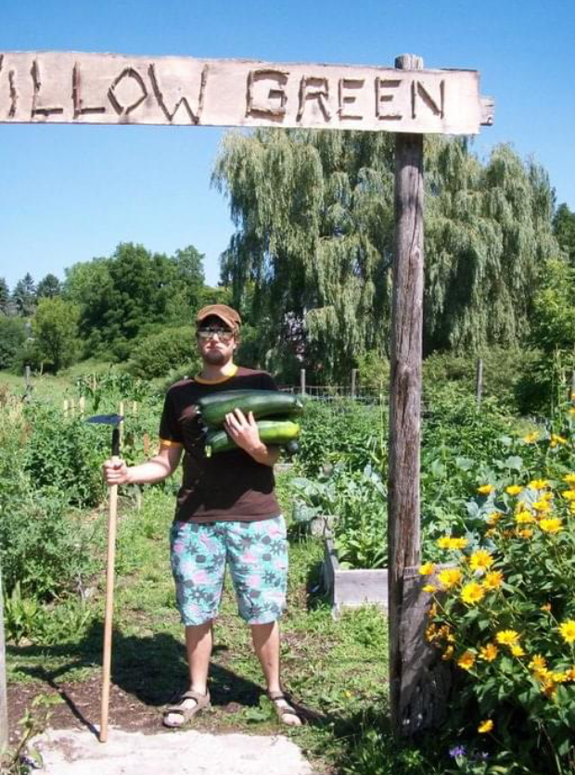
About twelve years ago, when Kris and I were fairly newly married and living in Kitchener-Waterloo, Ontario, we got pretty seriously into gardening. We lived in a small basement apartment with no yard, so we got ourselves a plot at a community garden right down the bike trail from our place. Through the long Ontario growing season, we would bike over almost every evening – with our compost in my bike basket! – and tend to our overflowing little plot. (If you’re following along with the sermon document, you can see a photo of a younger Kris with an armful of massive zucchini). I have very fond memories of that time of experimenting with growing fresh food for ourselves. Most of it was trial and error – we didn’t have much experience with gardening, but a lot of it worked! Over the years, the practice of gardening – whether in a community plot, on our balcony, or in our yard – has brought us a lot of peace and satisfaction.
Someone asked me the other day what I’m doing for self-care during this time of pandemic and physical distancing. One of my practices is preparing for and dreaming about our backyard garden. I’m currently nursing my little tomato and cantaloupe seedlings and planning out where to put the squash, potatoes, beans, and even broccoli! I get my kids involved (this counts as a science experiment for homeschooling, right?) and they are getting excited about helping grow our family’s food this year. But this year, because of the pandemic, the practice of gardening feels like it’s taken on even more significance. And we’re not the only ones taking up gardening right now. Apparently, there has been a big increase in Canadian orders of home gardening supplies, as many see growing their own food as a natural extension of the stay-at-home health guidelines.
But beyond the self-sufficiency and practical factors, gardening has a cultural and spiritual significance, perhaps especially in a time of crisis such as a pandemic. In her book, And It Was Good, Madeleine L’Engle writes about planting her garden in a time when the threat of nuclear war cast a long shadow. She writes, “In the spring, the early spring, during the height of the Falkland crisis, I knelt on the damp earth planting onion sets, and smelling the rich growing odour of the freshly turned garden, and the pungency of the onions. Planting onions that spring was an act of faith in the future, for I was very fearful for our planet. … So I planted onions, and hoped, and prayed, and suddenly I was aware of being surrounded by the song of the birds, making an ecstasy of melody, and their joy was a strengthening of hope … an affirmation of ultimate all-rightness … despite the news to which we were anxiously listening.” Could it be that planting gardens right now, in the midst of this pandemic, is also an act of faith in the future? It strikes me as an act of great hope in the God of life – the God of resurrection, who can bring new life even out of situations of fear and death. In this sense, planting a garden can be an act of faith, a spiritual practice of nurturing new life that will in turn nurture our bodies and spirits.
Earlier this year, our adult education classes focused on this theme of gardening as a way of allowing ourselves some comfort during the coldest part of winter. In exploring the symbolism and cultural, spiritual, and ethical aspects of gardens, we found there was a lot to dig into! The Bible, after all, starts with the garden of Eden in Genesis and ends with a garden in Revelation. In many ways, our Scriptures identify us as “people of the garden” – that is a central metaphor in our faith tradition. So as we move into spring and summer and the time of literally planting gardens, our worship will explore this fruitful theme.

Our first Scripture passage comes from Isaiah 65, a passage which also sees deep significance in planting and growing food. Verses 21 and 22 say, “They shall build houses and inhabit them; they shall plant vineyards and eat their fruit. They shall not build and another inhabit; they shall not plant and another eat; for like the days of a tree shall the days of my people be, and my chosen shall long enjoy the work of their hands” (Isaiah 65:21-22, NRSV). This section forms the centre of a vision that Isaiah has of what peace will look like in Jerusalem. A symbol of that peace is everyone having enough – in this case, a home and a garden from which to eat.
But what’s interesting is that Isaiah is not describing this in a time of peace. The book of Isaiah is about an extremely tumultuous and uncertain period of Israelite history – the Babylonian Exile. This was an event so traumatic that it provoked a theological crisis, as the Israelites wondered how God could have allowed the Babylonians to defeat their nation and even to destroy their beloved Temple in Jerusalem – not to mention carry off many of their people into exile in Babylon. In the midst of all this turmoil, of wondering how they could be God’s people outside of their homeland, Isaiah presented this vision of restoration and peace. God will recreate everything, Isaiah assured them. God will “create Jerusalem as a joy” without weeping or distress (v. 18-19), and people will live long lives (v. 20). Everyone will have a place to live and a garden to eat from – they will “enjoy the work of their hands” (v. 22-23). And he ends this passage with the famous vision of gentleness: “The wolf and the lamb shall feed together, the lion shall eat straw like the ox … They shall not hurt or destroy on all my holy mountain, says the Lord” (v. 25).
So we too, in this time of crisis, find ourselves turning to the meditative practice of gardening as a symbol of hope. It’s something tangible that we can measure in a time when a lot of things are so uncertain. Like Madeleine L’Engle, we may be fearing the unknowns of the future, but we can at least plant onions, taking things one day at a time. And this is probably not the first time in our family histories that seeds and gardens have offered this kind of comfort. Back in February in adult ed., I shared about the beans that we inherited from my spouse Kris’ grandmother. I was amazed that w e were planting heirloom seeds, literally descended from beans that she had grown for decades in her garden in Hague. And then I discovered that these were not only hers, they had actually been brought over from Russia when her family emigrated to Canada in the 1920s. My own Russian Mennonite roots are from way back in the 1870s, so I was floored to have this tangible connection to Russia in the form of beans we were growing and eating and feeding to our growing kids!
It turns out that many Mennonite families found gardening so central to their identities that when it was time to emigrate, seeds were among their most prized possessions that they brought – sometimes even smuggled! – into Canada. Historian Susie Fisher writes about “stories of cuttings from a yellow rosebush brought over from Russia and confiscated by immigration officials, of seeds sewn into the hems of dresses and hidden in corsets, of dolls stuffed with beans or wheat.” One of the more famous examples is the 800-year-old oak tree in the Ukraine called the Chortitza Oak, from which many acorns have been taken and sprouted by Mennonites in North America, but Fisher also lists the seeds of “melons, plums, marigolds, zinnias, and many other plants that once grew in Russian gardens.” Imagine gardens being so important that seeds would be treated with such reverence! These were clearly more than just seeds and gardens, but represented a culture and way of life, specific foods and an identity that Mennonites who emigrated to Canada wanted to recreate or transplant when they moved so far from their former homeland. And I’m sure other cultural groups have similar stories – their own version of the beans from Russia that I’m planting in my garden this year.

As we find ourselves a couple of weeks after one of the strangest Easters of our lives, marked by the absence of gathering in person with our beloved community, I have found myself noting the gardens that appear even in the Passion and Easter stories. The Garden of Gethsemane is, interestingly, not a comforting garden, but one in which Jesus suffers fear and betrayal. And in the Gospel of John, Jesus’ burial place is also portrayed as a “new tomb” in a garden (John 19:41), just as many of our cemeteries today are garden-like and beautiful places of rest. Perhaps this is why the reading by Margie McCreless Roe from our Good Friday Tenebrae service stated, “In the tomb / Christ is planted at last / like a sacred seed.”
In our Scripture for today from John 20, we read about Mary Magdalene coming to that garden cemetery to grieve, and finding the tomb empty. She is not comforted by the knowledge that the tomb is empty – rather, this causes her more distress as she assumes that not only has her teacher and friend been crucified and killed, but now his body has also been stolen (v. 13)! So when the risen Jesus appears to her, it takes her a moment to realize who he is. She doesn’t recognize him at first through her tears. “Jesus said to her, ‘Woman, why are you weeping? Whom are you looking for?’ Supposing him to be the gardener, she said to him, ‘Sir, if you have carried him away, tell me where you have laid him, and I will take him away’” (v. 15). And Jesus says, “Mary!” He calls her by name, and that is when she realizes who he is, calling him “Rabbouni!” or “Teacher.” And he sends her on her way with the message of the good news, of the new life of resurrection, which she is to proclaim to the other disciples (v.16-18).
I don’t think it’s a mistake that Mary supposes him to be the gardener. We’ve focused a great deal in church history on the image of Jesus as the Good Shepherd, but here we have an equally profound image of Jesus the Gardener: the one who sows the seeds and tends the seedlings and blesses them with water and sunlight. Jesus the Gardener, who brings life out of dry, seemingly lifeless seeds, buried in the darkness of the earth. Jesus the Gardener, who brings us new life again and again – though sometimes in ways we don’t recognize right away.
There is a long tradition of viewing the cross as a Tree of Life (this photo is from the Canadian Mennonite University chapel in Winnipeg). This is not a way of saying that suffering is what saves us, or that it is ever God’s will that we suffer. But it speaks to God’s ability to be present with us and redeem even situations of terrible suffering and violence, to bring life even out of death and hopelessness. It is a symbol above all of the power of resurrection. As a way of symbolizing this Tree of Life cross, some churches have the practice of covering a wooden cross with flowers on Easter morning. This is known as “flowering the cross,” and Sarah Bessey describes it this way: “For Easter every year, we set up an actual old rugged cross [in our church]. It’s covered in chicken wire, the beams are old and knotted, and it towers above all of us with a crude but solid base. The first time I saw it, I thought it was the weirdest and ugliest thing I’d ever seen – a harsh, unrelenting reminder. But at the end of our worship service, here is what we do as a community: we cover that old rugged cross in blossoms. We thread tulips and daisies and chrysanthemums through the chicken wire, and when we are done, that cross is blooming with new life, beauty out of bedlam and brokenness.” To me, this flowering Tree of Life cross is exactly the kind of cross that corresponds with Jesus the Gardener and we who are people of the garden.
As we continue our post-Easter journey in these unusual times, I invite us to look for ways in which God is bringing new life to us. Perhaps this takes the form of unexpected connections or reconnections we are making with neighbours or family members. Perhaps we are watching new life literally grow as we plan out our gardens. Perhaps we are finding new ways to cultivate and foster gratitude in the face of uncertainty. Whatever form it takes, I invite us to pay attention to these signs of new life, and to recognize them as the presence of the God of Life and Peace among us. AMEN

Benediction: Sing the Story #158

https://www.macleans.ca/society/some-canadians-are-turning-to-their-yards-to-grow-their-food-during-the-covid-19-pandemic/
Madeleine L’Engle, And It Was Good (Wheaton, IL: Crosswicks, 1983), 22-23.
Manitoba Correspondent, “Why Mennonites Love Their Gardens,” Canadian Mennonite 19/11 (May 20, 2015), https://canadianmennonite.org/stories/why-mennonites-love-their-gardens.
Ibid., and Susie Fisher, “(Trans)planting Manitoba’s West Reserve: Mennonites, Myth, and Narratives of Place,” Journal of Mennonite Studies 35 (2017): 127-8.
“In the tomb / Christ is planted at last / like a sacred seed. / The agony is over. / Safe, / finally, / from thorns / and nails and spears. / God is very still / and a great vacuum builds / at the heart of things. / The guards of this world / are lulled into drowsiness / beside the stone. / A profound ignorance fills this last / moment / before sunrise. Alleluia From: Margie McCreless Roe, “Holy Saturday,” Christian Century 3/23 (30/94), 304.
Sarah Bessey, Out of Sorts: Making Peace with an Evolving Faith (Toronto: Howard Books, 2015), 94.

