The Tree of Life
Co-Pastor Susanne Guenther Loewen
NPMC – June 14, 2020

Scripture: Proverbs 3:13-18, Revelation 22:1-5
Hymn: HWB 509

Our 6-year-old is a fan of David Suzuki and his science and nature show, The Nature of Things. These past couple of months, in the ups and downs of homeschooling, he’s watched an episode of The Nature of Things here and there. It counts as “science class,” right? One of the episodes I watched with him was all about trees, and something that has stayed with me is that trees are capable of communicating with one another through their root systems – so forests aren’t a collection of individual trees, but actually a community of trees that interact with each other, that are in relationship with each other. Trees have a social life! Not only that, but trees are capable of helping each other. When one tree isn’t getting enough water or is in less nutritious soil, the other trees can send it water and nutrients through their roots, and ensure it survives and thrives. Trees, in other words, are capable of altruism, of helping those most vulnerable in their midst. Amazing.
Trees are, of course, a very important symbol in the Bible. Our sacred Scriptures begin and end with trees, from the Tree of the Knowledge of Good and Evil and the Tree of Life in the Garden of Eden to the Tree of Life with healing power at the end of Revelation, to the vines and fig trees and mustard seeds in between, some of which we’ve already touched on in this worship series on Gardens. Today, I want to dive a bit deeper into the meaning of the Tree of Life and its connection to Jesus.
I want to start in a somewhat unfamiliar place in the Bible – in the book of Proverbs. Now these might seem like a bit of filler after the book of Psalms – a collection of largely irrelevant ancient cultural sayings. But they contain a very intriguing biblical figure: Woman Wisdom, or the personified Wisdom of God, who is female. God’s Wisdom is portrayed as a prophet and host of a meal of bread, wine, and meat, as a house builder, as co-creator in the beginning with God, as God’s child, and as an exemplary Israelite wife, among other images. In Proverbs 3, as we heard, Wisdom is also called a tree: “She is a tree of life to those who lay hold of her; those who hold her fast are called happy” (v. 18). In the midst of all the statements about her being more valuable than jewels, and her ways leading to wealth and honour, she is also called a tree of life, which leads to happiness. What could this mean?
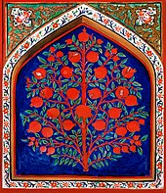
Well, it’s not in all of our Bibles, but in the Apocrypha (extra books included in Catholic Bibles), there is more material about Wisdom as a Tree of Life. This image is expanded in the book of Sirach, also known as Ecclesiasticus (not to be confused with Ecclesiastes). In chapter 24, Wisdom herself makes a speech, telling of how God sent her to dwell among the Israelite people as a tall, fragrant and fruitful tree:
“Thus in the beloved city [God] gave me a resting place,
and in Jerusalem was my domain.
¹² I took root in an honored people,
in the portion of the Lord, his heritage.

¹³ “I grew tall like a cedar in Lebanon,
and like a cypress on the heights of Hermon.
¹⁴ I grew tall like a palm tree in En-gedi,
and like rosebushes in Jericho;
like a fair olive tree in the field,
and like a plane tree beside water I grew tall.
¹⁵ Like cassia and camel’s thorn I gave forth perfume,
and like choice myrrh I spread my fragrance,
like galbanum, onycha, and stacte,
and like the odor of incense in the tent.
¹⁶ Like a terebinth I spread out my branches,
and my branches are glorious and graceful.
¹⁷ Like the vine I bud forth delights,
and my blossoms become glorious and abundant fruit.

¹⁹ “Come to me, you who desire me,
and eat your fill of my fruits.
²⁰ For the memory of me is sweeter than honey,
and the possession of me sweeter than the honeycomb.
²¹ Those who eat of me will hunger for more,
and those who drink of me will thirst for more.” (Sirach 24:11-21)

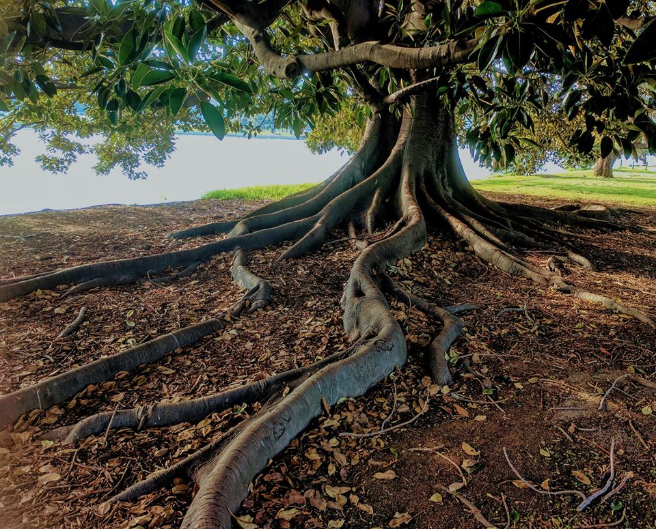
As a tree of life, then, Wisdom offers both shade and delicious fruit. She is a life-giving tree offering shelter and food to those she invites to come to her, to take refuge under her branches and to eat of her delightful and sweetest of fruit.
Now I personally find Wisdom interesting because she’s kind of a bridge between other trees in the Bible. You might remember that at the beginning of Genesis, there are actually two trees in the garden of Eden: the Tree of the Knowledge of Good and Evil and the Tree of Life. Adam and Eve eat of the first one – the Tree of the Knowledge of Good and Evil, and are banished from the garden so they won’t eat of the second one – the Tree of Life. But another word for “the knowledge of good and evil” in the Bible is wisdom. In Wisdom, these two trees become one, as Wisdom – the knowledge of good and evil, wise discernment and decision-making – is declared to be the Tree of Life. In Proverbs and all the passages about Wisdom, we find that God actually wants us to eat of this tree – God wants us to be wise and to have life in abundance. God made it so that wisdom – wise living – leads to a full and good life; they’ve become the same symbolic tree. Along these lines, I’ve heard an interpretation of Genesis that says it was never about the Tree of the Knowledge of Good and Evil remaining forbidden forever – it was simply that Adam and Eve gained knowledge and wisdom before they were ready for it rather than gaining it according to the timing of God’s plan for that gift. It was a matter of getting the timing all wrong – and if we think back to our own childhoods or think about the young people in our lives, this question of timing and age-appropriate knowledge makes a lot of sense. It’s not that we want to shelter our young people from certain difficult topics forever, but rather that this knowledge needs to be shared with them when they are ready.

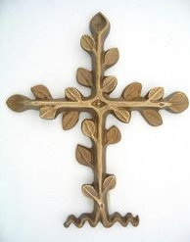
Coming back to that last verse from Sirach 24, we hear echoes of another piece of the puzzle. Wisdom says, “Those who eat of me will hunger for more, and those who drink of me will thirst for more” (v. 21). Sound familiar? In John 6:35, Jesus says, “I am the bread of life. Whoever comes to me will never be hungry, and whoever believes in me will never be thirsty.” It’s almost the exact opposite statement, and it’s a major hint about the connection between Wisdom and Jesus in the New Testament. You see, Jesus takes on many of the roles that Woman Wisdom has in the Hebrew Bible: Jesus becomes that prophet in the streets, Jesus becomes that host, that Wisdom or Word of God become flesh, and yes, that Tree of Life. So Jesus becomes the Tree that gives us the fruit of wisdom and leads us into life. Jesus is the Apple Tree, like our special music affirmed (HWB 509). And with Jesus’ life, death, and resurrection, the Tree of Life takes on yet another meaning: it becomes combined with the cross. The crucifixion in some Bible verses is described as “hanging on a tree” (Acts 5:30, Gal. 3:13). In recognizing that Jesus’ way of nonviolence and solidarity with those on the margins led to his death but also the new life of resurrection, the cross, that instrument of torture, that tree of death, becomes a living tree. Dorothee Soelle speaks of discipleship as our struggle for life and peace in the Way of Jesus; through this process, “the dead wood” of the cross “will turn green and blossom.” The cross becomes the Tree of Life.
I’ve thrown a lot of symbolism at you here, so kudos if you’re still with me! We’ve seen how the two trees of Eden become one in divine Woman Wisdom, and then Jesus and his cross take on this title of Tree of Life. So what does all of this symbolism mean for us today as we live out our faith in our time and place? Given the Black Lives Matter protests that have been going on across North America and elsewhere, I thought of African American theologian James Cone and his book, The Cross and the Lynching Tree. Dr. Cone powerfully connects the tragic history of the lynching of thousands of Black people in the Southern U.S. from 1880-1940 – which some argue continues today, just in other forms (police brutality, the death penalty, etc.) – he connects this history with the cross. From the excruciating experience of having Black community members killed arbitrarily by white people with no repercussions, Dr. Cone says many turned to their faith, making the connection to Jesus as “the ‘first lynchee,’” who was likewise killed unjustly by hanging on a tree. And in this connection between Christ’s suffering and that of African Americans, in claiming that “God transformed lynched black bodies into the recrucified body of Christ,” such that “Every time a white mob lynched a black person, they lynched Jesus,” Dr. Cone reveals the power of the cross. This connection is found in the well-known Spiritual, “Nobody knows the trouble I see, / Nobody knows but Jesus.” It was this connection to Jesus, this view of the cross as a lynching tree, that gave people courage - “It was Jesus’ cross that sent people protesting in the streets, seeking to change the social structures of racial oppression” in the Civil Rights movement of the 1960s. Could something similar be at work in the protests today? Could God be working a similarly profound change in the current refusal among so many to accept unjust deaths as inevitable? Could this be another instance of the tree of death, the cross, becoming a green and blossoming and fruitful Tree of Life, spurring us all to life-giving change, to take further steps toward justice and peace?
Some of us have started to have conversations about what racism means in our own, Canadian context, and in our history and the present as a Mennonite community here in Saskatoon – a fitting conversation for June, Indigenous History Month. These are important, if difficult, conversations, and they are conversations that will take time. Intergenerational systems of discrimination won’t go away in one conversation, or in one sermon, for that matter! The important thing is that we keep listening and talking about this and working at this. We’re not going to get this right immediately, but in the words of Cornel West, “We try again, fail again, and fail better.” I like that as a starting place.
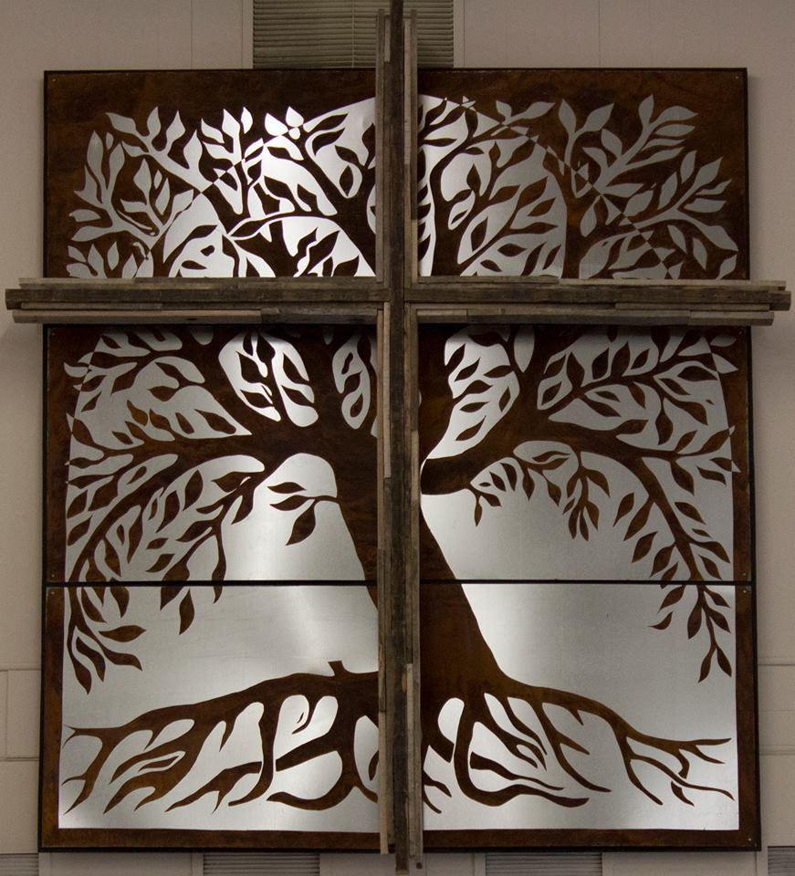
I want to close with the vision of the Tree of Life in the book of Revelation, chapter 22. There, we find that there is a Tree of Life somehow bridging two sides of the river of life. This tree produces twelve kinds of fruit, one each month of the year, so that there is always good fruit on its branches. “And the leaves of the tree are for the healing of the nations.” This is the tree that gives us wisdom or knowledge, that sets us on the path of life, that feeds us with the fruit of compassion and connection, that roots us in the love of God for the sake of the healing of the nations. In the words of Mi’kmaq/Acadian theologian Terry LeBlanc: “Right relationship with the creator, the human community, and the rest of creation is within our grasp. It is made possible by the One who provides for creation’s healing – the Tree of Life. Justice is one of the leaves.” AMEN

https://www.cbc.ca/natureofthings/features/canadas-boreal-forest-is-a-thriving-social-community-of-trees-that-work-tog
Susan Cady, Marian Ronan, and Hal Taussig, Wisdom’s Feast: Sophia in Study and Celebration (New York: Harper and Row, 1989), 26.
Dorothee Soelle, Theology for Skeptics: Reflections on God, trans. Joyce L. Irwin (Minneapolis: Fortress, 1995), 104.
James H. Cone, The Cross and the Lynching Tree (Maryknoll, NY: Orbis, 2011), 158.
Cone, 21, 28.
The tree of life image on this page is from the chapel at Canadian Mennonite University, created by Clare Schellenberg and Unger. Terry LeBlanc, “Tree of Life, Healing Justice,” in Wrongs to Rights: How Churches Can Engage the United Nations Declaration on the Rights of Indigenous Peoples, ed. Steve Heinrichs, special issue of Intotemak (May, 2016): 108.

