Vine & Vineyards
Co-Pastor Susanne Guenther Loewen
NPMC – May 10, 2020

Scripture: 1 Kings 21:1-19, John 15:1-11
Hymn: HWB 373

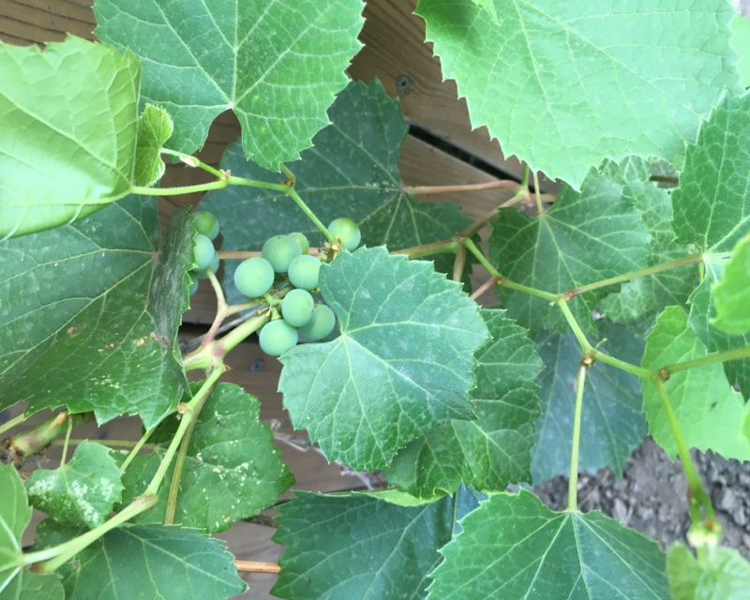
Last summer, our neighbour’s grapevine grew through the fence onto our side. At first, it was just a tendril of vine, with those broad leaves like outstretched hands. By August, a single tiny cluster of green grapes had grown (see picture). And in the fall, we shared those sour-sweet, purple Concord grapes, my kids and I, with the toddler picking and gobbling up most of them.
I was reminded of this unexpected second-hand gift of a handful of our neighbour’s grapes when reading our Scripture for this week, on grapevines and vineyards. These are very common topics in the Bible, with grapes, grape juice, and wine being such central foods in biblical times and cultures. On the one hand, they were a very ordinary part of everyday meals and celebrations. But on the other, they took on this deeper meaning within the symbolism of the Bible. For Christians, they connect Jesus’ parables about vineyards to his first miracle of turning water into wine, to the cup as one of the two elements of Communion – and, of course, Jesus’ self-designation as the True Vine, which we’ll return to.
In our first Scripture passage, the story of Naboth’s Vineyard from 1 Kings 21, we get some sense of the importance of vineyards in the Hebrew Bible or Old Testament. This story of King Ahab who covets his neighbour Naboth’s vineyard and obtains it by grossly unjust means involving trumped-up charges and the execution of an innocent man, is meant to be unsettling, even horrifying. This is a portrait of Israelite leadership at its most corrupt, at the time when Israel was in moral and spiritual decline, even free-fall – a state which would, in the Israelite understanding, eventually lead to the destruction of the first Temple and the devastating experience of the Babylonian Exile.
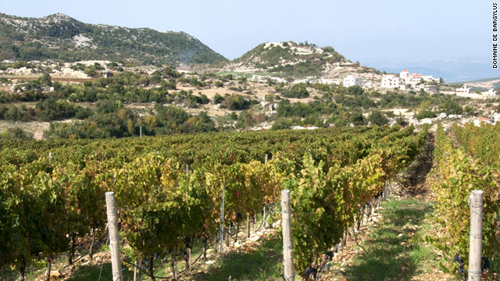
A few details caught my attention as I sat with the text this week. One is that at first glance, King Ahab’s offer to Naboth doesn’t actually seem unjust. He says, “Give me your vineyard, so that I may have it for a vegetable garden, because it is near my house.” This seems pretty reasonable, and he even makes what seems like a generous offer: “I will give you a better vineyard for it; or, if it seems good to you, I will give you its value in money.” But Naboth refuses, saying, “I will not give you my ancestral inheritance” (1 Kings 21:2-3, NRSV).
This interaction reveals that there is actually more going on under the surface. Why, for instance, would a king be trying to amass more land for himself – he presumably has all the land he could possibly need, so what does it say about his priorities that he’s trying to obtain more? And Naboth’s language of “ancestral inheritance” gives us another clue as to the completely different relationship he has with his vineyard. It’s not a commodity to be bought and sold, but the land promised to his family so that they would be able to feed themselves; this is not about the money for him, but about holy ground. It brings to mind imagery of Jubilee justice, of the Shalom or peace preached by the biblical prophets of everyone having their own place to live and their own vine and fig tree (Micah 4:4, and remember Isaiah 65 from a couple of weeks ago). This is about everyone having enough. As king of the Israelites, Ahab was supposed to be protecting the ancestral rights of his people, not trying to buy their land out from under them! His priorities are all wrong, here. He is showing terrible selfishness as a leader, and breaking the basic command to love God and his neighbour.
And these bad priorities show themselves as things quickly escalate when Naboth refuses to sell his sacred land. After moping and acting like he’s the victim of the situation, King Ahab essentially gives Queen Jezebel free rein to do whatever it takes to get the vineyard for him – or at least, he asks no questions and does not protest. She then arranges for Naboth to be executed on false charges, and he is stoned to death, leaving King Ahab free to take his vineyard for himself. So Elijah the prophet immediately comes to confront Ahab on this serious injustice he has perpetrated: “Have you killed, and also taken possession?” (v. 19). It is an eerie echo of King David’s sins of arranging to have Uriah killed in battle so he could marry Bathsheba – a crime the prophet Nathan also deems evil and condemns him for (2 Samuel 11-12). It’s a matter of these kings abusing their power to have people killed if they stand in the way of their whims. Rather than fostering justice, these kings are themselves violating the sacred rights of their own people. It shamefully reveals just how far the kings have strayed from God’s ways of justice, righteousness, and the Shalom vision of each having enough.

As we turn to our Gospel passage from John 15, it becomes clear that we are moving from literal vineyards into the symbolism of what it means to be vines in God’s vineyard. This metaphor is actually found in the Hebrew Bible as well – for instance, in Psalm 80, where it is applied to Israel. Israel is described there as a vine that God has transplanted from Egypt, that has taken root and grown (v. 8-9). So what could Jesus mean in applying this metaphor to himself?
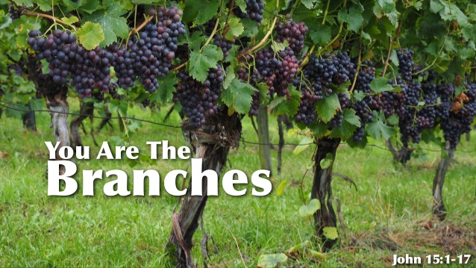
Like so many of Jesus’ teachings, what we see here is a reinterpretation of his Jewish tradition to emphasize the centrality of love of God and neighbour – what King Ahab found so challenging. “I am the true vine, and my Father is the vinegrower,” Jesus says (v. 1). “I am the vine, you are the branches. Those who abide in me and I in them bear much fruit, because apart from me you can do nothing” (v.5). Jesus is speaking here of rooting ourselves as disciples in the Way of Jesus – that is our source of strength, the way the tendrils and branches rely on the sturdy grapevine for support, especially as they produce heavy fruit. What I love about the Gospel of John is that even though Jesus is depicted as very divine – almost more divine than human – he is also depicted as fostering a mutual relationship with the disciples. In other words, Jesus empowers the disciples in John, speaking of mutual connection and, in the passage just following this one, calling them “friends” instead of “servants” (v. 12-17). A more modern translation simplifies our passage this way: “I am the vine. You are the branches. You live in me and I in you; we are connected. When you are connected to the vine, you will produce a lot of fruit. If you do not stay connected to the vine, you cannot produce any fruit. So stay connected to me.” And what is the substance of this connection? It’s not unquestioning obedience, but love: “I have shown you God’s strong love. Stay close to my love.” If we cultivate and nourish our connection to Jesus and his way of love, Jesus promises good, life giving fruit. This means that his joy will be in us; we will experience complete joy (v. 11).
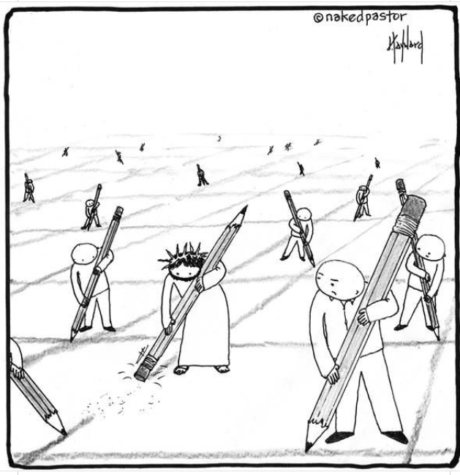
I have been thinking a lot about connection these days as we try to reimagine what connection and community look like during this pandemic. My two-year-old is at the stage of establishing her independence. But instead of saying “I’ll do it all by myself,” she’s been saying, “I do it all myself!” This could really be the mantra of individualism, couldn’t it? I think that in our culture, we tend to idealize being self-sufficient islands, looking after ourselves alone. But what this pandemic has brought to light is that we really are all connected to one another. Our decisions affect the people around us – we aren’t isolated individuals, but members of a community. Our lives are intertwined with those of our neighbours, and we need each other. Right now, we are very much aware that our health depends on each other’s willingness to follow health guidelines and not take unnecessary risks. It reminded me of this cartoon of Jesus erasing the boxes we draw around ourselves – the ways we keep people at arm’s length rather than being honest and vulnerable with one another, which leads to true connection. Jesus erases the obstacles to connection and love, reminding us that we’re all connected to the same vine.
I’ve been listening to Brené Brown’s podcast, called “Unlocking Us.” In one of the episodes, she talks about how anxiety is one of the most contagious emotions. When one person is anxious, those around them tend to “catch” it. But the same is also true of calm. “Calm is also contagious,” Brown says, “but it's a daily intention and practice.” Calm is also contagious, but we have to work at it; it doesn’t just happen. So as we move into another week of this unusual time, I invite us to cultivate a rootedness in Christ our Vine as we branch out toward our neighbours in love. What are ways we can respond to our situation with calm and connection, making sure our neighbours have enough of what they need? What can we do to spread the life-giving connection that we bear as branches of Christ’s vine, rooted in God’s vineyard? I invite us to live into these questions with joy, growing and bearing good fruit in our love of God and neighbour. AMEN [Benediction: StS 158]

Ziony Zevit, “1 Kings Introduction,” Jewish Study Bible (JPS, 1985), http://www.oxfordbiblicalstudies.com/article/book/obso-9780195297515/obso-9780195297515-chapter-10
https://crossref-it.info/articles/62/vine-vineyard
“The Vine and the Branches,” in Shine On: A Story Bible (Kitchener, ON: Mennomedia, 2014), 262.
https://brenebrown.com/unlockingus/ and https://www.facebook.com/brenebrown/posts/three-learnings-that-have-been-life-shifting-for-me1-anxiety-is-one-of-the-most-/3338606419487777/

